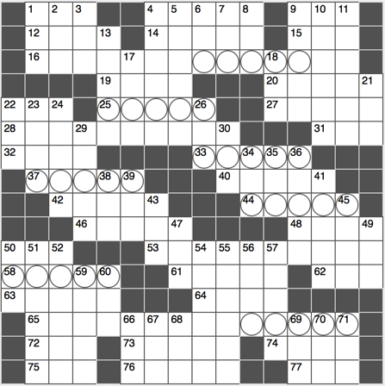**Across**

1. Foreman striker?
2. Auto mechanic on “The Andy Griffith Show”

9. “Spring forward, fall back” inits.

12. Thor’s brother

14. Desert islands

15. Festive Greek shout

16. First part of a Walt Whitman quote, hinted at by the series of circled letters

19. Calf-length garment

20. Western Australia’s capital city

22. Org. for tall men

25. Copper alloy

27. Bye in Bordeaux

28. Second part

31. Communist Mao ____-tung

32. Cashmere, for instance

33. Spoiled children

37. Defeats

40. Supreme Court Justice Samuel

42. Completely unemotional

44. The Goldilocks trio

46. One of the theme parks at Walt Disney World

48. Dog food brand with a paw print on its logo

50. “Now let me think”

53. Third part

58. Retailer since 1886 that shared its name with the tallest skyscraper in Chicago until 2009

61. Faux butter spreads

62. Goo used in a do

63. Popular pastry for Dunkin’

64. Obsolete dichotomy: “she ____”

65. Fourth part

72. Period on a time line

73. Formal request

74. Wine opener?

75. Speedy internet connection letters

76. Like a college student’s place

77. Like much sushi

**Down**

1. Pie ____ mode
2. “That’s hilarious!” in text messages
3. Presidential nickname
4. Skilled in
5. Stupidly clumsy
6. Chinese food additive
7. Always, poetically
8. Nelson Mandela’s country, abbr.
9. Administered medicine to
10. Lindbergh’s ____ of St. Louis
11. Sweetness and umami, for example

13. Shakespeare’s feet?

17. Like many Christmas trees

18. Mud bath milieu

21. Subtle tint

22. L.A.-to-Seattle dir.

23. ____ tube

24. Plants used in cosmetics

26. Religious day of rest, abbr.

29. Thrill

30. Org. with many arms

34. Minister’s attire

35. 0-0 game, e.g.

36. Start of many cases?

38. Apogee

39. ____ semper tyrannis

41. Chimp relative

43. Army bed

45. Captain Hook’s subordinate in Peter Pan

47. Shortened “on the other hand”

49. Word part, abbr.

50. EUR competitor

51. Responded cattily?

52. Large estates

54. God, in the Hebrew Bible

55. ____ Clarkson, former Top Gear presenter

56. Sounds of wonderment

57. Is of ____ (helps)

59. Far from the city

60. NYSE part, abbr.

66. Anxious condition, for short

67. Progressive spokesperson

68. Road covering

69. Aviation prefix

70. Essential macromolecule

71. Litter producer